DehuTech™ 7000 Desiccant Dehumidifier

#### **DehuTech™** desiccant (adsorption) dehumidifiers are developed, designed and produced to meet the highest demands for high capacity, low energy consumption, reliability and simple maintenance.

All desiccant dehumidifiers are fitted with a high performance adsorption rotor that is washable, incombustible, chemically inert and mechanically stable.

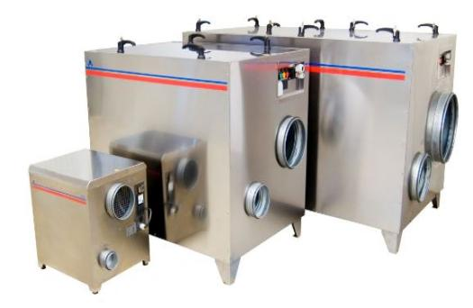

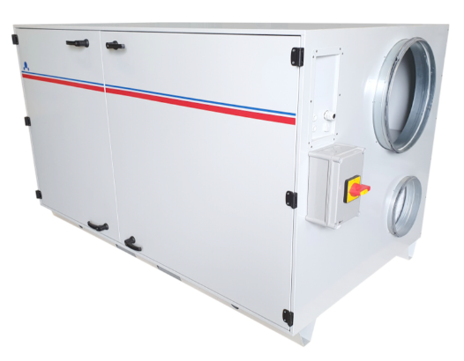

**DehuTech™ 7000** desiccant dehumidifier is delivered as a complete unit with fans, filter, rotor and controls. The dehumidifier is ready for site installation and connection to standard-size ducting and electrical mains (3 x 400V 50Hz).

Features

* Insulated powder coated casing.
* Built-in PLC with touch screen as standard.
* Rotation guard, filter alarm, run-time-meter and service alarm as standard.
* Reactivation heater type according to customer specifications.

Accessories for DehuTech™ 7000

* Mounted pre/post cooler.
* Pre/post treatment modules.
* Air cooled condensor.
* DDC controls
* Moisture control via external moisture sensor.
* Step-less control via 0-10V signal.
* Communication with building management system via Modbus, Canbus or via Web server.

